|  |
| --- |
| Department of Software Engineering  Mehran University of Engineering and Technology, Jamshoro |

|  |  |  |  |
| --- | --- | --- | --- |
| Course: SWE324 – Distributing Computing | | | |
| Instructor | Rabeea Jaffari | **Practical/Lab No.** | 05 |
| Date | 02 April 2019 | **CLOs** | CLO-4: P3 & P4 |
| Signature |  | **Assessment Score** | 1 Marks |

|  |  |
| --- | --- |
| Topic | To become Familiar with OLTP System Design |
| Objectives | * To Creating applications using Datagram sockets. |

|  |
| --- |
| Lab Discussion: Theoretical concepts and Procedural steps |

|  |
| --- |
| Lab Tasks |
| Submission Date: 09-04-19 |

1. Task1:

1)Server

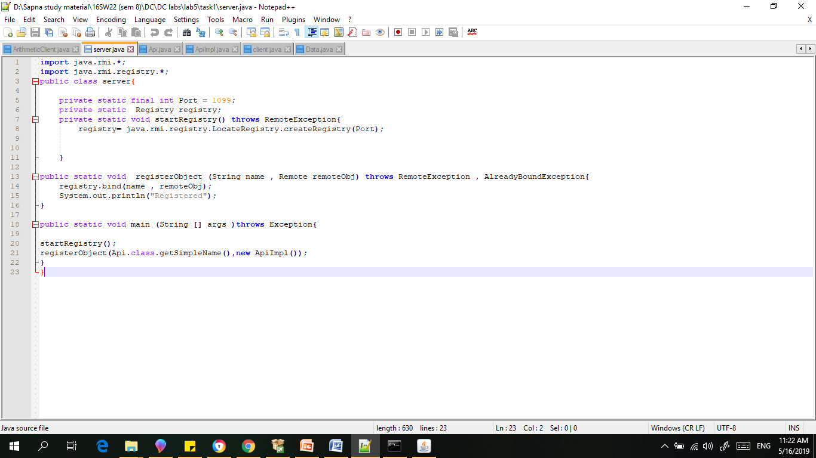

2)Api

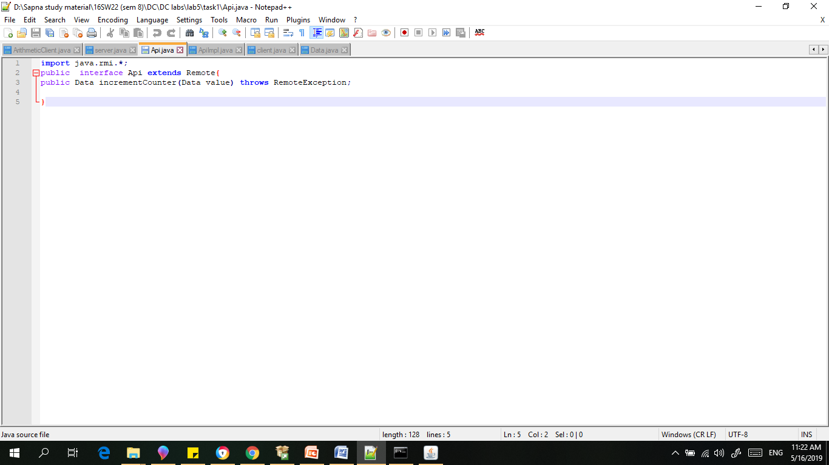

3) ApiImpl

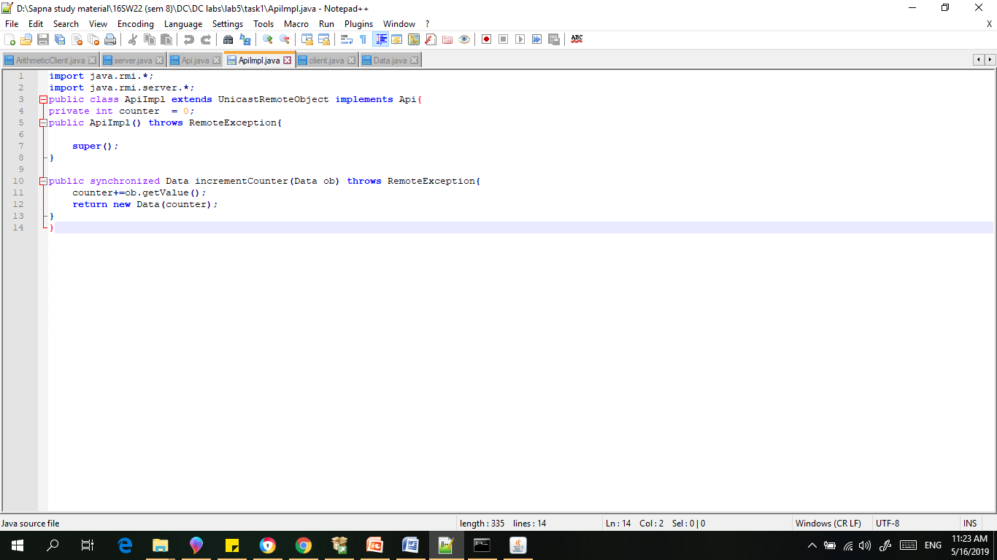

4)Client

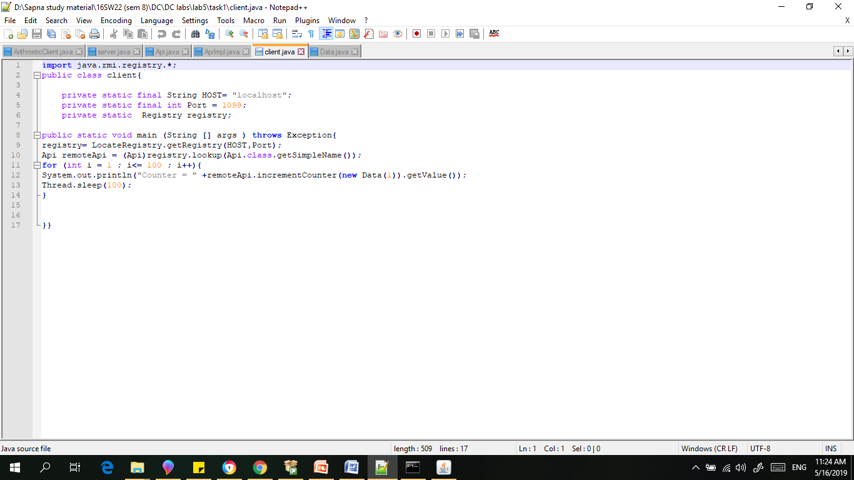

5) Data

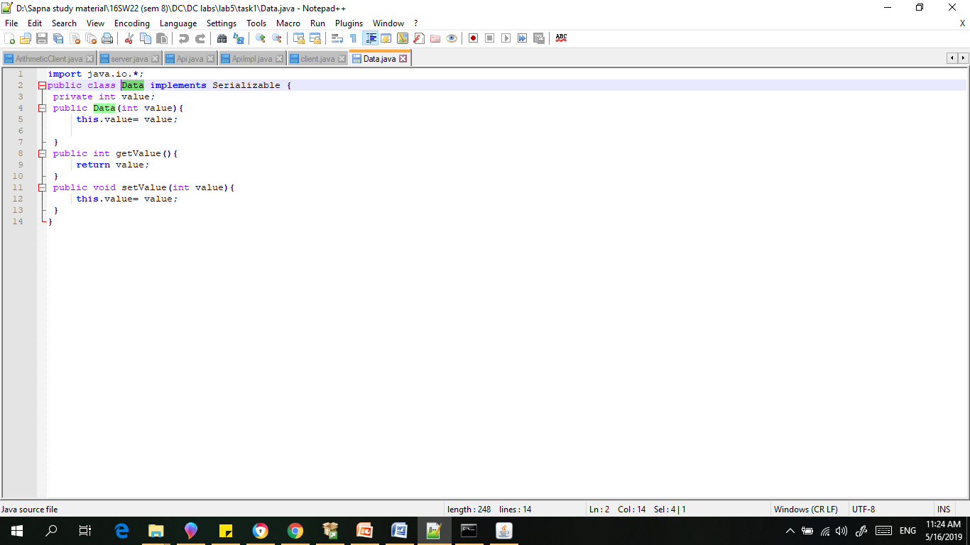

Result:

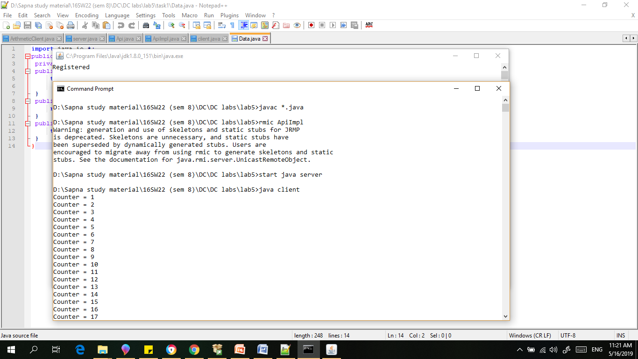

1. Develop any simple application to demonstrate object passing in RMI. (Expl: Make a class of your own and use its objects as arguments and return types for RMI)

1)Server



2)Api



3) ApiImpl



4)Client

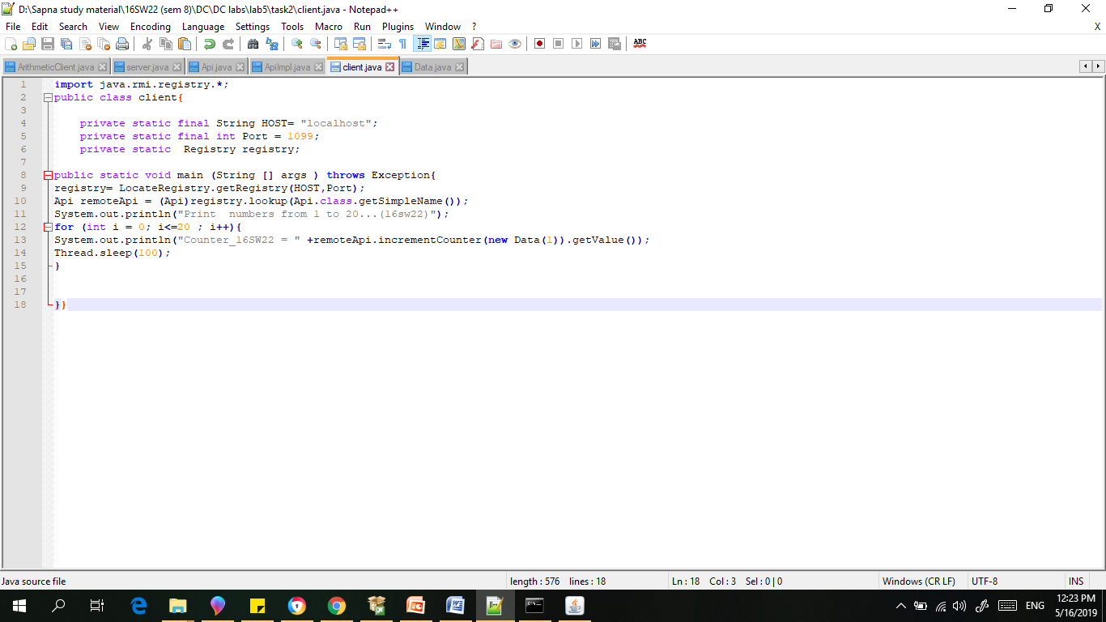

5) Data



Result:

